**CS5542 – Big Data Analytics and Apps**

**Lab 3 – Assignment Submission**

Name: Lava Kumar S

Class ID : 38

**1. Spark Programming:**

Please find the code, input and output in the below GitHub link:

**Linear:**

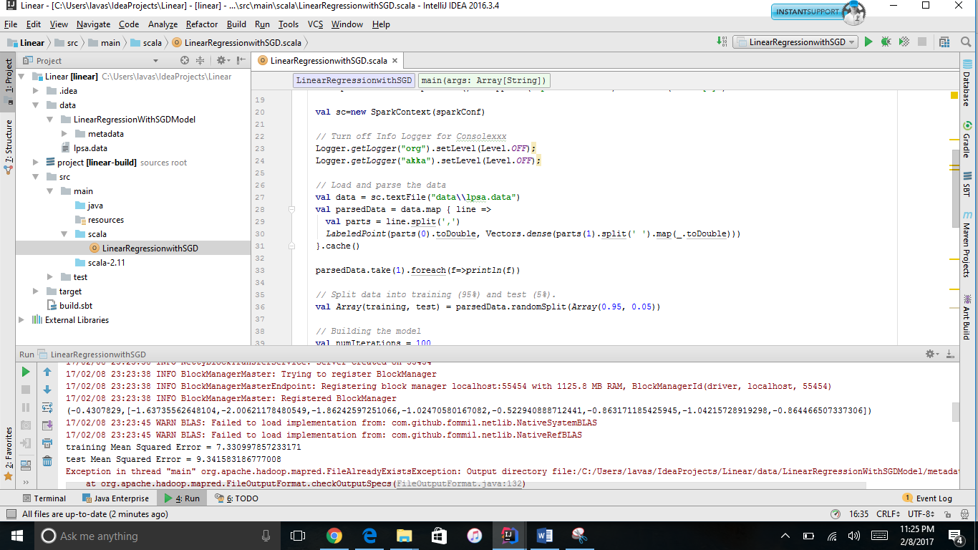

**K-means:**

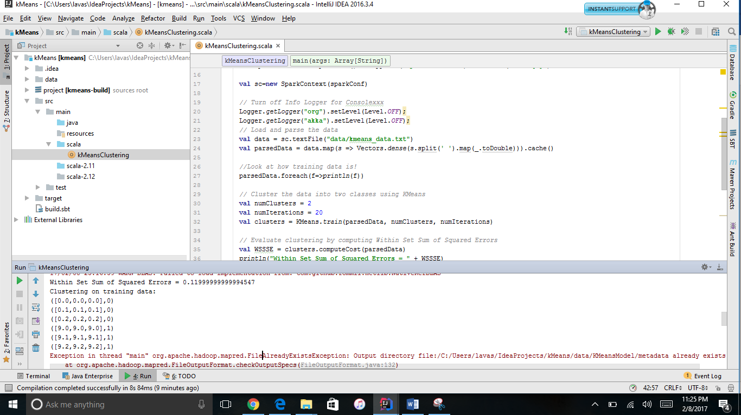

**2. Video Annotation:**

Please find the code, input and output in the below GitHub link:

